February 20, 2022

***Sent via Email:*** <<OPPOSING_COUNSEL_EMAIL>>

<<OPPOSING_COUNSEL_NAME>>

Re: <<PROVIDER_SUITNAME>> v. <<INSURANCECOMPANY_NAME>>

Case Number: <<INDEXORAAA_NUMBER>>

<<OPPOSING_COUNSEL_NAME>>:

Please find enclosed a draft copy of Plaintiff’s Motion for Sanctions pursuant to Florida Statute § 57.105 (2019). Please be advised in the event Defendant fails to withdraw its Motion to Dismiss and/or in the alternative Motion for Summary Judgment within twenty-one (21) days, our client has instructed our office to file this Motion with the Court.

It is Plaintiff’s position that Defendant’s Motion to Dismiss is frivolous as it is neither supported in fact or law.

It is clear that Defendant’s Motion to Dismiss is frivolous in this matter and should be withdrawn. Please contact the undersigned should you wish to discuss this matter in greater detail.

Sincerely,

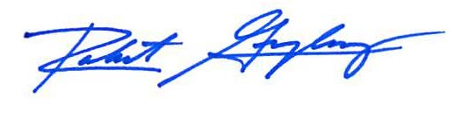

Robert F. Gonzalez, Esq.